# Setup

## New Project

* Create a new 2D Unity project called SpaceShooter

## Content Folder

* Create three new folders in Unity to store content
  + Sprites
  + Scripts
  + Objects
* Download the SpaceShooter Assets from Moodle
  + Copy the sprites into the Sprites folder in Unity (**there should be 5 sprites**)
  + Remember if you downloaded a ZIP file you must extract the contents of the folder first

## Scene Layout

* Add the space background to the scene and scale it to fill to the cameras view bounds
* Add 4 barriers to enclose the play space
  + Ensure the top barrier is well above the top of the camera view bounds
  + Ensure the bottom barrier is a little below the camera view bounds
* Add the players ship to the bottom of the scene

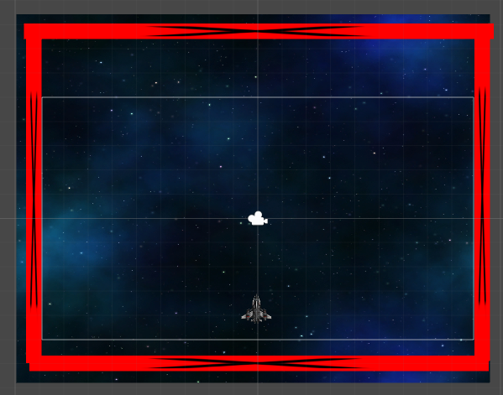

## Tags

We want two new tags to be created for this week. Tags allow us to categorise a range of objects under the one identifier.

To create a Tag. Select any object in the scene and select the Add Tag from the dropdown in the Tag box found in the inspector. Create the two new Tags:

* Enemy
* Kill

# Objects

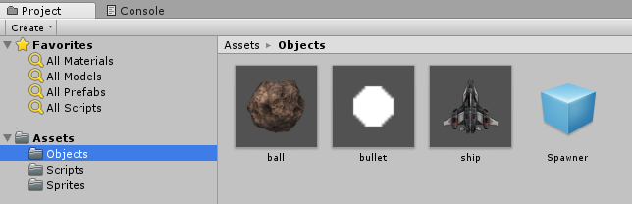

We want to create four objects (PreFabs) for use later on. The components can be added either before or after the prefabs have been created.

* Asteroid
  + CircleCollider2D
  + RigidBody2D (Mass = 0.01, Gravity Scale = 0)
* Bullet
  + CircleCollider2D
  + RigidBody2D (Gravity Scale = 0)
* Ship
  + PolygonCollider2D
  + RigidBody2D (Gravity Scale = 0)
* Spawner
  + BoxCollider2D (Is Trigger box should be checked)

### To create an object

* Drag the sprite of that object into the scene
* Then drag from the scene hierarchy into your objects folder

### To create the Spawner

* Right click in the scene hierarchy and select Create Empty
* Rename this object to be Spawner
* Then drag from the scene hierarchy into your objects folder

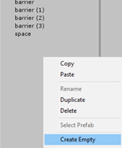

# Enemy Controller

This script will be added to the Ball object found in the Objects folder of your project

## Variables

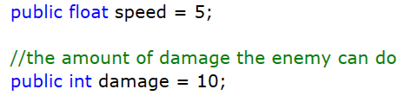

## Movement (Update Method)

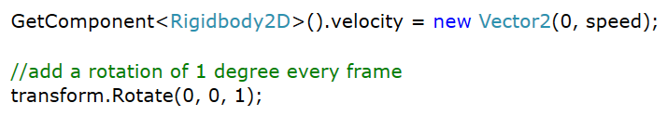

## Collisions

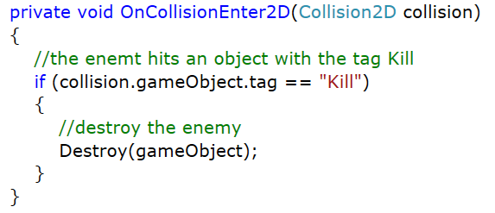

# Player Controller

* The player will control a ship
* The ship can only move horizontally
* The player will be able to shoot bullets
* The player will have a health value and if it reaches zero then the game is over

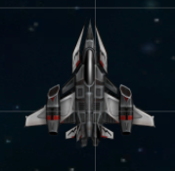

This script will be added to the Ship object found in the Objects folder of your project

## Variables

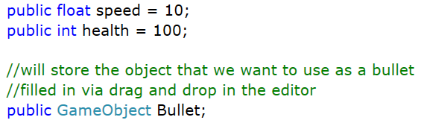

## Movement (Update Method)

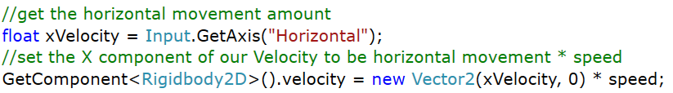

## Health Check (Update MEthod)

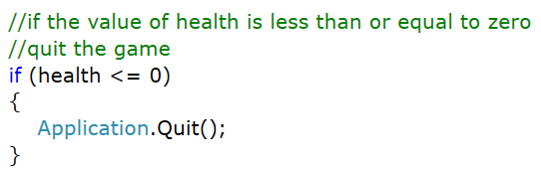

## Firing Bullets (Update MEthod)

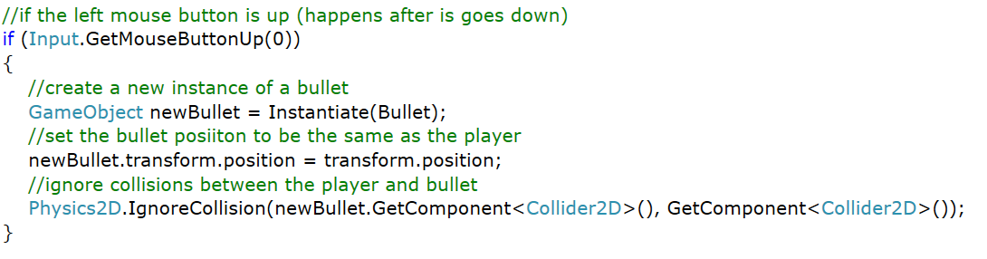

## Collisions

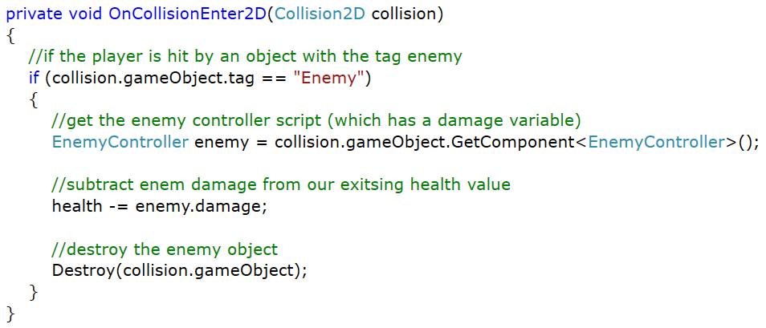

# Bullet Controller

This script will be added to the Bullet object found in the Objects folder of your project

## Variables



## Movement (Update MEthod)



## Collisions

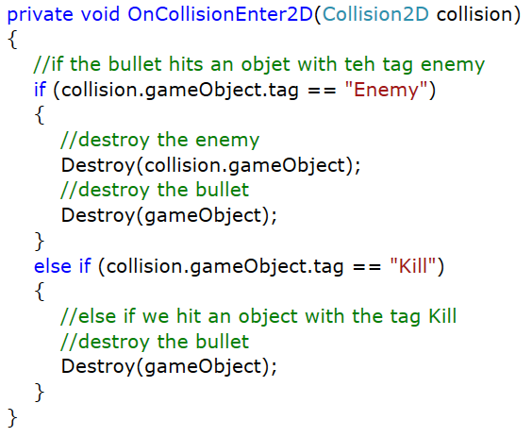

# Spawner

This script will be added to the Spawner object found in the Objects folder of your project

## Variables

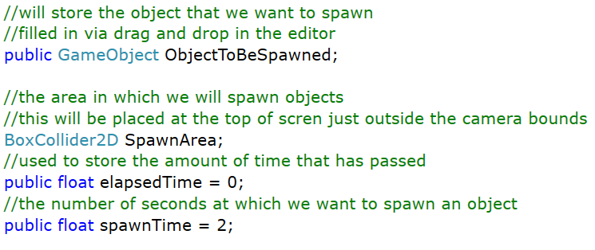

## Start

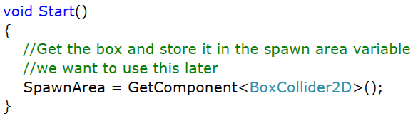

## Random Position

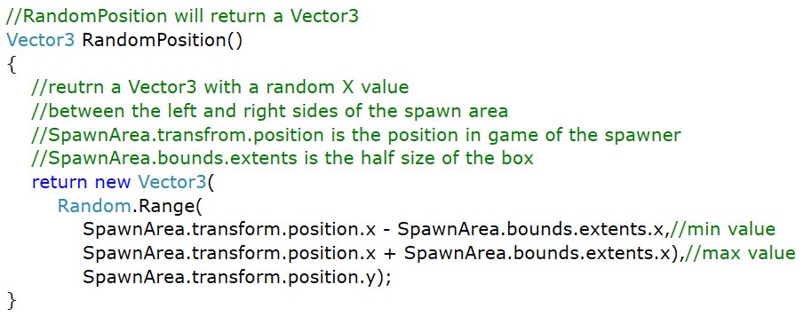

## Update

